Notice under The Local Authorities (Executive Arrangements) (Meetings and Access to Information) (England) Regulations 2012.

The making of the decision, Museum Estate and Development Fund grant, which is due to be made by Cabinet on 17th April 2025 is urgent and cannot reasonably be deferred because the offer of the grant is only open from 20th March 2025 for one month.

Tamworth Borough Council is therefore unable to comply with the requirements under The Local Authorities (Executive Arrangements) (Meetings and Access to Information) (England) Regulations 2012 Paragraph 9 in respect of Publicity in connection with key decisions.
In accordance with the General Provisions (Paragraph 10) of the Local Authorities (Executives Arrangements (Meetings and Access to Information) England) Regulations 2012 (the Regulations), a key decision, that has not been included on the Forward Plan can still be taken provided that it is impractical to defer the decision until it has been included on the next Forward Plan and;
1. | The Chair of the Scrutiny Committee has been informed
2. | The Proper Officer has made available to the public copies of the notice given to the Chair of the Corporate Scrutiny Committee at the offices of the Council and its website
3. | At least five clear days have elapsed since the Proper Officer complied with the above

Tamworth Borough Council has taken the following steps to comply with the requirements under The Local Authorities (Executive Arrangements) (Meetings and Access to Information) (England) Regulations 2012 Paragraph 10.

- The Proper Officer (Chief Executive Officer, Stephen Gabriel) can confirm that the Chair of the Corporate Overview and Scrutiny Committee, Councillor Samuel Smith has been notified in writing that the making of the key decision is urgent, cannot reasonably be deferred, and has agreed for it to proceed.

- The Proper Officer has made arrangements for this notice to be made available at the Council Offices at Marmion House, Lichfield Street, Tamworth, B79 7BZ and on the Council’s website;

The Local Authorities (Executive Arrangements) (Meetings and Access to Information) (England) Regulations 2012 (legislation.gov.uk)

- That at least 5 clear days will have elapsed prior to the decisions being made on 17th April 2025.

I am therefore satisfied that The Local Authorities (Executive Arrangements) (Meetings and Access of Information) (England) Regulations 2012 paragraphs 10 has or will have been complied with.

Signed
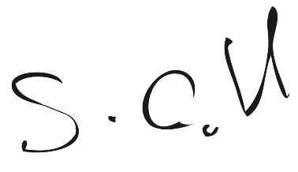
………………………………………………………………..
Stephen Gabriel
Chief Executive Officer

Dated 31st March 2025

