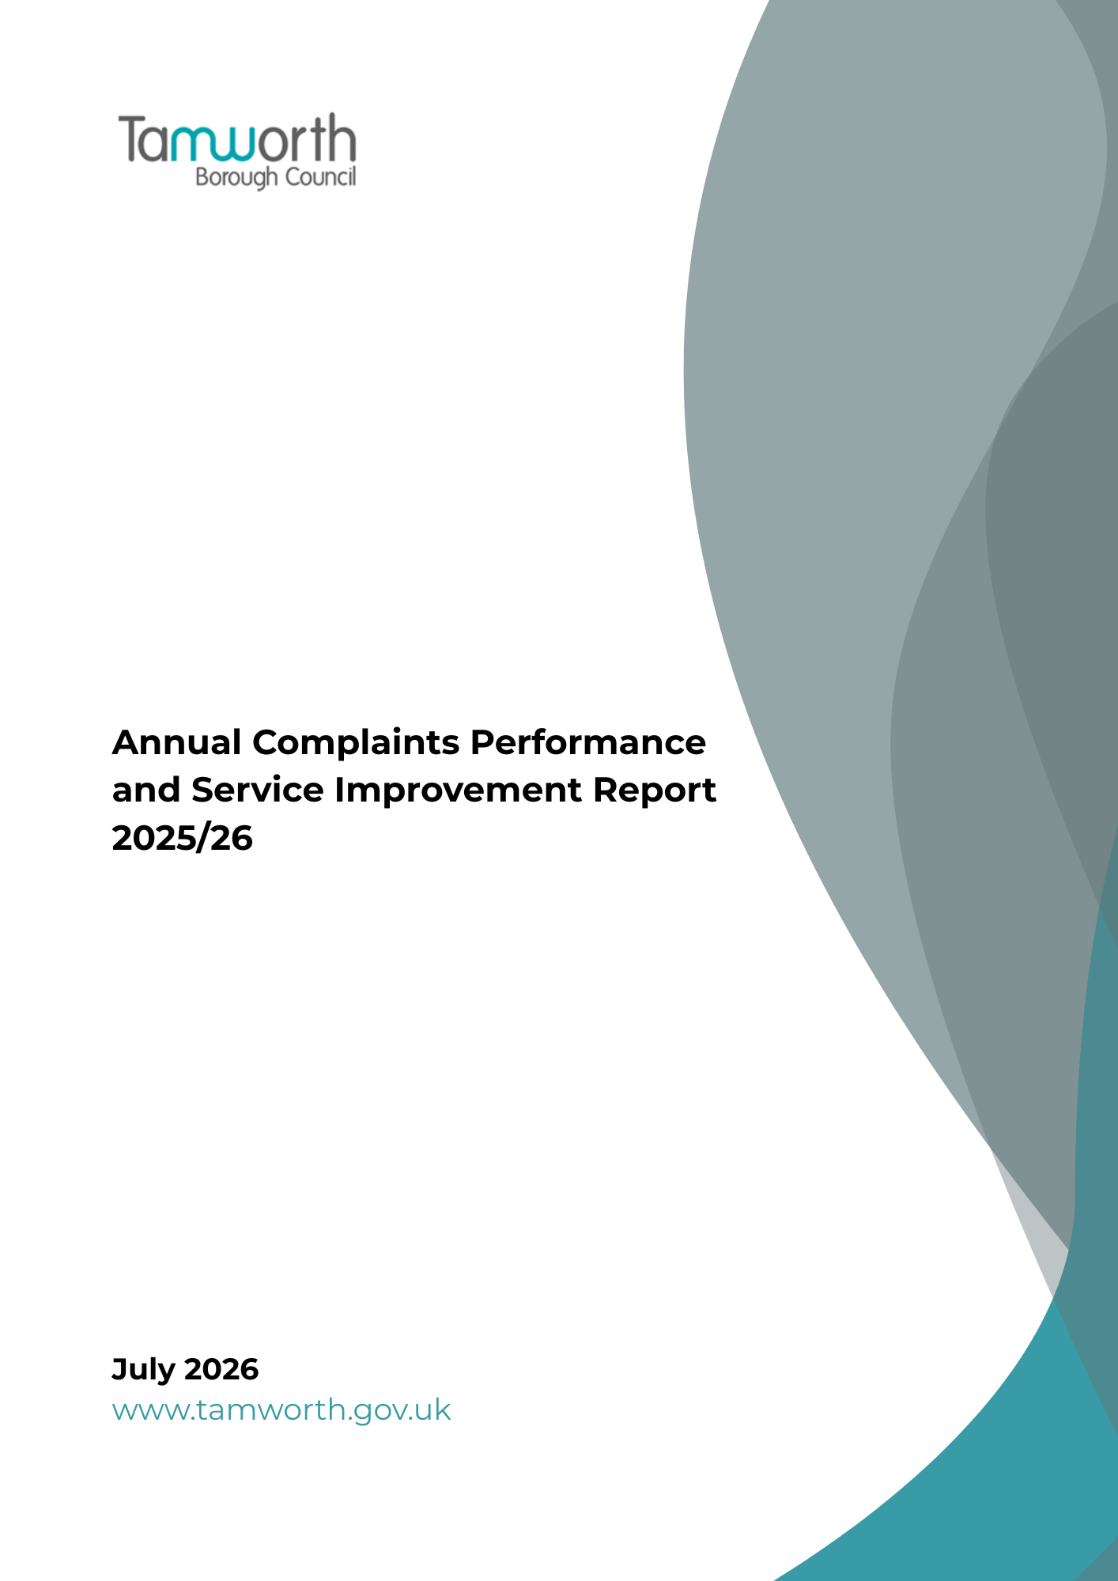
Report Contents

Introduction

Annual Self-Assessment

Analysis of Complaint Handling Performance

Learning from Complaints and Service Improvements

Housing Ombudsman Service Landlord Performance Report

Governing Body Response to the Report

Appendices

Introduction

Purpose of this report

This annual report sets out how Tamworth Borough Council has handled housing-related complaints during 2025-2026, what residents’ feedback has told us, and how we are using that learning to improve services. It forms part of the Council’s wider commitment to transparency, accountability and continuous improvement, and supports our ambition to Build a Better Tamworth by listening carefully when residents tell us something has gone wrong.

This is the Council’s third annual complaints performance and service improvement report. It summarises the volume and nature of housing-related complaints received during the year, how complaints were responded to, what themes and trends were identified, and what changes have been made as a result. It also explains how the Council has assessed its compliance with the Housing Ombudsman’s Complaint Handling Code and how learning from complaints will inform priorities for the year ahead.

Regulatory context

This report has been prepared in line with the Housing Ombudsman’s Complaint Handling Code. The Code requires social housing landlords to produce an annual complaints performance and service improvement report, complete an annual self-assessment, present both to the governing body, and publish the report and governing body response on the landlord’s website. The annual submission deadline to the Housing Ombudsman is 30 September.

The Complaint Handling Code became statutory on 1 April 2024 under the Social Housing (Regulation) Act 2023. This means the Council is required to demonstrate that its complaint handling arrangements meet the Code and that learning from complaints is used to improve services for residents.

What the report covers

- The volume and nature of complaints received
- Response times and resolution outcomes
- Key themes and trends identified
- Lessons learned and service improvements made
- Future commitments to enhance service quality
- A summary of the types of complaints the Council has refused to accept

The report focuses on housing-related complaints because these fall within the scope of the Housing Ombudsman’s Complaint Handling Code. Where relevant, it also reflects wider corporate learning from comments, compliments and complaints so that common themes can be considered across services.

The report also includes:

- the annual self-assessment against the Code, confirming whether the Council’s complaint handling policy remains aligned with its requirements;
- the governing body response to the self-assessment;
- any findings of non-compliance with the Code by the Ombudsman;
- any annual report about the Council’s performance from the Ombudsman; and
- any other relevant reports or publications produced by the Ombudsman relating to the Council’s work.

How complaints are managed

The Information Governance Team coordinates the Council’s corporate complaints process, including comments, compliments and complaints. The team works with service areas to make sure complaints are acknowledged, investigated and responded to appropriately, while also identifying learning and agreeing actions to reduce the risk of similar issues happening again.

The Council operates a two-stage complaints process. Stage 1 provides the initial formal response and Stage 2 provides the Council’s final response. For housing landlord complaints, residents may refer their complaint to the Housing Ombudsman at any stage.

Our commitment to learning

Complaints help us understand where residents’ experience has fallen short and where services need to improve. We use this feedback alongside performance information, customer insight and service reviews to identify root causes, agree actions and monitor progress. This approach helps us move beyond resolving individual complaints to making wider improvements that benefit residents.

Annual Self-Assessment

Since 2023, the Council has completed and published an annual self-assessment against the Housing Ombudsman’s Complaint Handling Code. This provides assurance that the Council’s complaints policy, procedures and practice are reviewed regularly against the Code’s requirements and that any areas for improvement are identified and acted on.

The 2025/2026 self-assessment has been completed and confirms that the Council remains broadly compliant with the Complaint Handling Code. The assessment identified strengths in the Council’s complaints policy and governance arrangements, while also highlighting areas where practice can be strengthened further. These include embedding a more consistent approach to complaint resolution across service areas, improving staff confidence in early resolution, and continuing to monitor the impact of resource pressures and service demand on response times.

Appendix 2 sets out the full 2025/2026 self-assessment against the Housing Ombudsman’s Complaint Handling Code.

The assessment considered the Council’s published complaints policy, complaint handling procedures, governance arrangements, performance monitoring and learning from complaint outcomes. This helps ensure that compliance is considered not only through written policy, but also through how complaints are managed in practice.

The self-assessment found strong compliance with the Code across the Council’s policies, procedures and governance arrangements. Key strengths include:
- A two-stage council complaints process
- A universal complaint definition
- Complaint acceptance, acknowledgement and extension timescales are aligned with the Complaint Handling Code.
- Complaints performance is reviewed through established officer and member governance arrangements.

The self-assessment also identified areas where the Council can strengthen practice further. The improvement priorities below have been identified as key areas of focus because they will improve consistency, oversight, use of data, response times and the resident experience.

Improvement priority | Actions
Better use of complaint data and insight | Strengthen how complaint data is analysed so that themes, trends, repeat issues, upheld complaints, response times, service areas and root causes are reviewed together. This will help the Council identify where issues are happening most often, understand what is driving complaints, and agree more targeted service improvements.
Response times and consistency | Continue to improve Stage 1 and Stage 2 response times by monitoring performance trends, identifying causes of delay, reviewing demand and capacity pressures, and agreeing targeted actions with service areas where Code timescales are not being met.
Ownership, action tracking and resident updates | Strengthen monitoring of agreed complaint actions and remedies so that completion is evidenced, residents are kept informed, and service areas remain accountable for delivering what has been agreed.
Complaint learning and the resident journey | Use complaint data, customer feedback, service insight and satisfaction information to identify recurring issues, particularly around repairs, damp and mould, delays, repeat visits, communication, quality of work and contractor performance, and turn this learning into practical service improvements.

Analysis of Complaint Handling Performance

Complaint handling performance in 2025-26 shows both positive progress and areas where further improvement is needed. The Council has seen a significant increase in housing-related complaints, which provides valuable insight into residents’ experiences and shows that residents are continuing to use the complaints process to raise concerns. At the same time, increased demand has affected the Council’s ability to maintain consistent response times across the year.

Overall complaint volumes
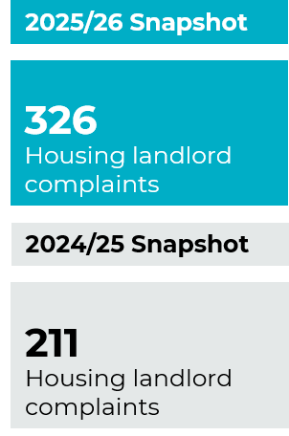
During 2025-26, the Council handled 326 housing landlord complaints, compared with 211 in 2024-25. This represents an annual increase of 54.5%. This shows that more residents are bringing issues to our attention and reinforces the importance of having clear, accessible and timely complaint handling arrangements.

An increase in complaints does not necessarily mean that services have worsened. It may also reflect improved access to the complaints process, greater resident confidence in raising concerns and better recording of feedback. However, we recognise that complaint data must be reviewed carefully so that we can understand where issues are linked to service delays, repeat contact or matters that have not been fully resolved.

Stage 1 complaints

There were 267 Stage 1 complaints in 2025-26, compared with 193 in 2024-25, an increase of 38.3%. Most complaints continued to be resolved or managed at the first formal stage, with 88% of Stage 1 complaints not escalating to Stage 2. This suggests that early resolution is generally effective and that services are able to address many concerns without the need for escalation.
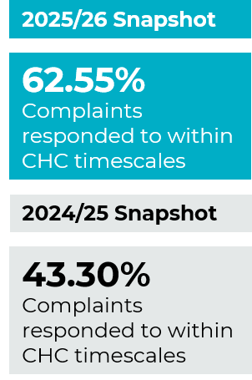
Timeliness is an area where further improvement is needed. Across the year, 62.55% of Stage 1 complaints were responded to within Complaint Handling Code timescales, which was an improvement on 43.30% in 2024-25. This shows progress in annual performance, while also highlighting the need to strengthen arrangements so that timely responses can be sustained as complaint volumes increase.

Stage 1 uphold rates remained relatively stable, with half of complaints upheld during the year. This helps identify where service standards have not been met and where learning should be focused, particularly where complaints relate to repeat issues, delays or communication.

Stage 2 complaints

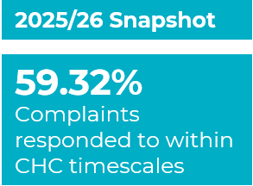
The Council handled 59 Stage 2 complaints in 2025-26, compared with 18 in 2024-25. Although Stage 2 volumes remain lower than Stage 1, the increase shows that more residents escalated their complaints during the year. Stage 2 complaints provide important assurance because they show where residents remain dissatisfied after the initial response and where further review is needed.

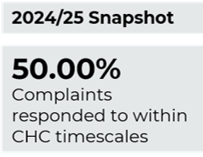
Stage 2 timeliness improved overall compared with 2024-25, with 59.32% of complaints responded to within timescale compared with 50.00% in the previous year. However, this remains an important area of focus for 2026-27, as timely escalation responses are essential to maintaining resident confidence and ensuring complaints are resolved effectively.

50% of Stage 2 complaints were upheld during the year, this provides useful learning about where issues were not fully resolved at Stage 1 and where earlier action may help reduce the need for escalation in future.

Complaint acknowledgement
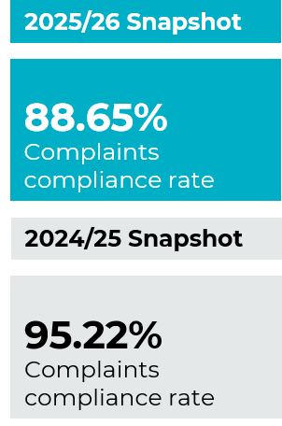
The Council maintained a stronger position in acknowledging complaints than in responding to them. Of the 326 complaints received during the year, 289 were acknowledged within the required timescale, giving an annual compliance rate of 88.65%. This demonstrates that the initial receipt and logging of complaints is generally working well.

The annual acknowledgement rate was lower than the 95.22% achieved in 2024-25. This suggests that rising demand has affected consistency at the start of the complaints process as well as at the investigation and response stages. Improving consistency will therefore remain a priority.

Service area themes and root causes

Complaints were heavily concentrated in Housing Repairs, which accounted for the largest proportion of Stage 1 complaints and the highest number of upheld complaints. This reflects the importance of repairs performance to residents’ overall experience of housing services.

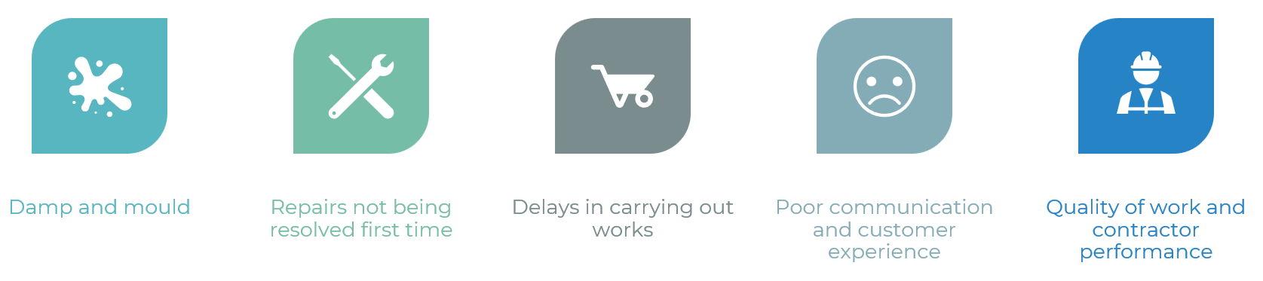
The main themes identified from complaints were:
These themes are closely connected. Delays, repeat visits, missed appointments and unresolved repairs can lead residents to contact the Council again because the original issue has not been fully resolved. Clear and timely communication is especially important in these cases, as it helps residents understand what will happen next, when work is expected to be completed and who is responsible for progressing the issue.

Overall assessment

Overall, the annual data shows that complaint handling arrangements are in place and that there has been progress during the year, particularly when compared with 2024-25. It also shows that increased demand, service pressures and the complexity of some cases have affected performance. The low escalation rate from Stage 1 to Stage 2 is positive, but the increase in complaint volumes, response-time performance and concentration of complaints in repairs-related services show where further improvement is needed.

The Council’s improvement focus for 2026-27 will build on this learning. Priorities include improving first-time resolution, strengthening contractor performance management, maintaining clear communication with residents, improving case ownership and tracking, and ensuring that learning from upheld complaints leads to practical service improvements.

Theme | What residents told us | Improvement focus
Damp and mould | Concerns about delays, repeat visits and issues not being fully resolved. | Improve diagnosis, communication and follow-through.
Repairs not resolved first time | Residents experienced repeat contact where repairs did not address the root cause. | Strengthen first-time resolution and contractor performance monitoring.
Delays in works | Routine repair issues sometimes escalated because works took longer than expected. | Improve tracking, ownership and updates to residents.
Communication and customer experience | Residents wanted clearer updates, better coordination and fewer missed appointments. | Provide clearer communication throughout the repairs journey.
Quality of work | Some complaints related to incomplete work or the need for further visits. | Use complaint learning to improve quality assurance and contractor accountability.

Learning from Complaints and Service Improvements

During 2025-26, complaint learning has continued to be used as an important source of insight into residents’ experiences of housing services. The annual performance data shows that complaint volumes increased during the year, with the strongest themes linked to repairs, damp and mould, delays, communication, quality of work and contractor performance. This section sets out how that learning has informed service improvement activity and how it will shape priorities for 2026-27.

The Council recognises that complaints are an essential part of service improvement. While the aim is always to get things right first time, complaints help identify where service standards have not been met, where residents have experienced avoidable frustration, and where processes need to change.

Where the Council has not got things right, the focus is on putting matters right for the resident and identifying what needs to change to reduce the risk of the same issue happening again. Complaint feedback will continue to be reviewed alongside customer satisfaction surveys, service performance data and resident insight to support targeted improvement during 2026-27.

During 2025-26, this learning has informed work with service areas to identify recurring themes, understand the root causes of complaints and agree actions to improve the resident journey. The focus has been on practical improvements that strengthen communication, ownership, timeliness and accountability.

Maintaining this proactive approach will help embed a stronger learning culture across housing services and support the Council’s wider commitment to transparency, accountability and continuous improvement.

In 2025-26, residents most frequently raised concerns about repairs, damp and mould, delays in completing works, repeat visits, communication and the quality of work. These themes have shaped the service improvement activity summarised below.

Theme/trend | Actions taken or planned to improve the customer journey
Housing Repairs  Most housing-related complaints in 2025-26 continued to relate to repairs. Common issues included damp and mould, repairs not being resolved first time, delays in completing the work, poor communication and the quality of completed work. | The Council has established a range of governance arrangements to monitor the performance of its repairs contractor and address service concerns. Operational performance is reviewed through regular meetings with the contractor, where service delivery issues, outstanding actions, and customer concerns are discussed.  In addition, formal monthly operational review meetings are held to examine performance trends, complaints, lessons learned, and opportunities for service improvement. Where issues cannot be resolved at an operational level, or where there are wider service concerns, these matters are escalated to the Core Group for further review and oversight.  Due to concerns regarding contractor performance, the Council has implemented enhanced governance arrangements through the establishment of a Project Board. The Project Board provides strategic oversight of performance improvement activity, monitors delivery against agreed action plans, and holds the contractor accountable for achieving the required service standards.  These arrangements are intended to ensure that performance issues are identified promptly, appropriate corrective actions are implemented, and service improvements are monitored and reviewed on an ongoing basis.
Housing Register | Finding a Home  Following the technological issues on the Council's finding a home website, complaints were received. During the outage the team continued to allocate fairly, openly and transparently via a direct lets system. Following complaints, customers were kept informed and the team worked jointly with colleagues in ICT to build a new webpage delivering all the previous functions of the finding a home platform. It has been a success and is easy to use. It has cost savings attached to this as this service is now delivered in –house and we no longer ned to pay for the external platform.  Housing Register Application decisions and banding  The team receive complaints regarding applicants  decisions on their housing application. Where circumstances have not been considered by staff, the team are now implementing with our ICT colleagues, further questions on the application form that will help with the filtering and assessment criteria. For example, the team have created and implemented a care leaver housing documentation checklist, which has been circulated both internally and with County Council to ensure we are working more harmoniously for the care leavers and their customer journey onto the housing register.  Disqualifications  Following complaints, the council has created a new pro-forma that is completed by advisors when applicants are applying to the register to manage expectations and mitigate further complaints if an applicant is disqualified or received reduced preference. The pro-forma allows advisors to seek management advice and follow up with customers the council's decision and why, which has negated further complaints.  Debt management applications  Feedback and training have been given to staff regarding applicants who are suffering from debt management issues and the need to refer to Tamworth Advice Centre (the councils commissioned service) on a more regular basis to target early intervention for applicants which will also assist in preventing homelessness
Housing Management | Tenancy fact sheet and clearer tenancy advice  During 2025-26, learning from a complaint about succession rights highlighted the need for clearer, more accessible information for tenants about tenancy arrangements. In response, a tenancy factsheet was co-designed together with tenants and was introduced to explain key responsibilities, available support and how tenants can raise issues if something goes wrong. This has helped improve consistency in the advice provided by officers, supported tenants to better understand what they can expect from the Council, and reduced the risk of confusion or avoidable contact. The factsheet also strengthens the customer journey by providing a simple reference point for tenancy-related enquiries, including succession rights.  Case ownership and early resolution  Complaint learning also reinforced the importance of clear case ownership where tenants raise tenancy management concerns. Housing Management will continue to focus on making sure tenants know who is dealing with their enquiry, what action is being taken, what timescales apply and when they can expect an update. This supports earlier resolution and helps prevent tenants having to repeat information or chase progress.  Anti-social behaviour and neighbourhood resilience  Where complaints or service requests relate to anti-social behaviour, neighbour nuisance or wider neighbourhood concerns, the focus is on improving communication, setting realistic expectations and keeping tenants informed about the steps that can and cannot be taken. Officers will continue to use tenancy conditions, partnership working and support referrals to respond proportionately, while recognising the impact that unresolved neighbourhood issues can have on tenants’ confidence and wellbeing.  Estate and tenancy management learning  Learning from Housing Management feedback will be used alongside estate inspections, tenant contact and service requests to identify recurring issues such as estate condition, communal areas, tenancy breaches, garden standards, abandoned items and vulnerability-related concerns. Bringing this information together will help officers identify patterns earlier, target intervention where it is needed and provide clearer feedback to tenants about action taken.  Record keeping and tenant vulnerability  A consistent theme from housing complaint learning is the need for accurate records, clear notes of decisions, and appropriate recording of tenant vulnerabilities or communication needs. Housing Management will continue to strengthen recording practice so that officers can understand case history, avoid missed actions, tailor communication where reasonable adjustments are needed, and provide better evidence if a complaint is reviewed.  Service standards and clearer information about housing services  During 2025-26, complaint learning highlighted that some tenants were not always clear about what services Housing provides, what standards they can expect, and the responsibilities of both the Council and the tenant. In response, Housing Services worked with tenants to develop a set of Housing Service Standards. These standards reflected the information that tenants told us was most important to them. The service standards have been published on the Council’s website and provide clear, accessible information about the services delivered by the Housing Department, expected response times, service commitments, and how tenants can access support or raise concerns. By setting out these expectations more clearly, tenants are better informed about what they can expect from the Council, helping to improve transparency, reduce misunderstandings and support a more positive customer experience. Complaint feedback demonstrated that dissatisfaction can sometimes arise where expectations are not fully understood or where tenants are unsure which service is responsible for an issue. The publication of the Housing Service Standards helps address this by providing a consistent point of reference for tenants and staff, supporting clearer communication, improved accountability and greater confidence in housing services.  Community Estate Days  Community Estate Days were introduced as a new initiative in 2025-26, enabling Housing Services and teams from across the Council to engage directly with residents in their local communities. The initiative provided accessible face-to-face support, including complaint handling and service advice, without residents needing to visit Council offices. They were well received, with strong engagement and positive feedback from attendees.  During 2025-26, Community Estate Days engaged 100 residents, generated 34 enquiries and supported the handling of 12 complaints.
Other areas of improvement | Public communication and transparency during 2025-26  During 2025-26, our communication continued to reinforce that complaints are a valuable source of resident feedback and an important driver for service improvement. Messaging focused on showing how the Council listens, responds and uses learning from complaints to improve the customer journey.  - Demonstrating the Council’s responsiveness to resident feedback.  - Highlighting improvements made as a result of complaints and service requests.  - Building transparency and trust by being clearer about what has changed and why.  Repairs contact centre  The team has introduced measures to identify and address issues early, helping to prevent complaints. These include daily 15-minute focus calls between planners and senior officers to resolve emerging issues. Themes from the case management review sheet are also captured and added to a joint action plan or addressed in the daily meet examples include third party contractor issues.  Improved technology  In spring 2026, new technology was introduced to strengthen the repairs contact centre, including call recording, call-back, webchat and translation functionality. Customers can also choose to stay on the line after their call to answer a few questions about their experience, helping the Council measure satisfaction and identify further improvements.  These tools make it easier for residents to access the service, reduce avoidable repeat contact and support quicker follow-up where further investigation is needed. Call recording also provides clearer evidence for complaint reviews and learning, while translation and digital options improve accessibility for residents who need additional support.  Marmion House reception  Face-to-face reception services at Marmion House continue to support residents with general enquiries, housing matters and access to services, particularly where additional assistance is needed.  Service request process improved  The service request process has been improved to make it clearer, more consistent and easier to track. The improved process also provides better visibility of recurring issues, helping the Council identify themes, address service failures and strengthen the overall customer journey.  Additional resource  A Resident Engagement Officer has been added to the information governance team to provide additional capacity to support housing complaint investigations and response. This role will help ensure residents are kept informed, evidence is gathered more consistently, and responses are clearer, more timely and focused on resolution. The additional resource will also strengthen the link between complaints, resident feedback and service improvement, helping the Council identify recurring themes and use learning to improve the customer journey.
Timeliness and resident updates | Stage 1 and Stage 2 response times improved compared with 2024-25 but remain an area for development. The Information Governance Team will continue to monitor overdue cases, provide reminders to service areas, escalate delays where needed and improve resident updates where timescales cannot be met. This will help reduce uncertainty for residents while their complaint is being investigated.
Action tracking and follow-through | Complaint responses often include actions or remedies that need to be completed after the response is issued. The Information Governance Team will strengthen how agreed actions are recorded, monitored and evidenced so that residents receive appropriate updates and service areas remain accountable for completing what has been agreed.
Data analysis and learning | Complaint data will be reviewed more systematically to identify themes, upheld complaints, repeat issues, root causes, service pressures and customer journey points where communication, ownership or resolution can be improved.
Training and staff awareness | Complaint learning has highlighted the importance of staff being confident in recognising complaints, distinguishing complaints from service requests, understanding Complaint Handling Code timescales, and providing clear information to residents. The Information Governance Team will continue to support staff awareness and training across service areas, including guidance on complaint definitions, escalation, extensions, reasonable adjustments, remedies, evidence gathering and the importance of timely resident updates. This will help improve consistency and support a more positive customer journey.
Policy and procedure review | The Information Governance Team will continue to review the Council’s complaints policy, templates and internal procedures to ensure they remain aligned with the Housing Ombudsman’s Complaint Handling Code and reflect learning from complaint outcomes.  Keeping policies and procedures under review will help ensure residents receive clear, consistent and Code-compliant communication throughout the complaints process.

Summary of Complaints refused

During 2025-26, 126 contacts received through the complaints route were assessed and redirected to the most appropriate route, rather than being handled as formal complaints. These contacts were service requests, enquiries, requests for information, or other types of contact that did not meet the definition of a complaint under the Council’s complaints policy.

Where this applied, the contact was reviewed on its individual merits and directed to the appropriate service area for action or response. This ensured that residents were still supported through the correct route, while maintaining a clear distinction between complaints and service requests in line with the Complaint Handling Code.

The Council will continue to review how contacts are categorised to ensure residents are not prevented from making a complaint where they express dissatisfaction with the response to, or handling of, a service request.

Learning from Housing Ombudsman publications

The Council also uses wider learning from Housing Ombudsman publications to test local practice, identify emerging risks and shape service improvement. During 2025-26, the most relevant publications for the Council’s housing services were those focused on repairs, damp and mould, complaint handling, resident communication and putting things right.

The Housing Ombudsman’s Annual Complaints Review 2024-25 reported continuing growth in complaints across the sector, with 7,082 determinations made during the year and 71% of complaints upheld. It also highlighted that local authorities and landlords with between 1,000 and 10,000 homes were experiencing particular challenges in providing timely complaint responses. This national context is relevant to Tamworth because the Council also experienced increased complaint volumes during 2025-26 and has identified response timeliness, repairs performance and communication as key areas for improvement.

The Ombudsman’s 2025 Spotlight report, Repairing Trust, reinforces the need for landlords to treat repairs as more than transactional work orders. The report identifies trust, empathy, communication, accurate diagnosis, effective contractor relationships and clear accountability as central to improving the repairs experience. This aligns closely with the Council’s local complaint themes, particularly where residents reported delays, missed appointments, repeat visits, poor communication or repairs not being resolved first time.

The Ombudsman’s learning on damp and mould has also informed the Council’s approach. Recent publications emphasise the importance of timely inspections, accurate diagnosis, clear records, resident vulnerability, risk assessment and follow-through where works are identified. This is particularly important as the sector prepares for strengthened expectations around damp, mould and housing hazards. Locally, this supports the Council’s focus on reviewing the damp and mould process, improving resident feedback, and ensuring that cases are tracked through to completion.

Housing Ombudsman publications consistently stress the importance of good knowledge and information management. Poor records can lead to missed actions, repeated resident contact, inconsistent responses and difficulty evidencing decisions. This learning supports the Council’s planned use of improved customer contact technology and casework processes to strengthen ownership, tracking and follow-up.

The Council will continue to review relevant Ombudsman publications, severe maladministration reports, spotlight reports and good practice guidance through the housing complaints working group. This will help ensure that national learning is translated into local action, including improvements to repairs diagnosis, contractor performance, complaint response quality, communication with residents, compensation decisions and monitoring of agreed actions.

Housing Ombudsman Service Landlord Performance Report

The Housing Ombudsman Service investigates complaints from tenants and leaseholders of social landlords, such as housing associations and local authorities, as well as from private landlords who voluntarily join the scheme. It acts as the final decision maker in disputes. In addition to resolving individual complaints, the Ombudsman encourages landlords to learn from these cases to improve their services and prevent similar issues from recurring. It also conducts systemic investigations to identify broader issues affecting residents and promotes good practice across the housing sector.

Where a complaint is accepted for investigation, the Ombudsman seeks to establish whether the member has been responsible for maladministration (which includes findings of service failure, maladministration and severe maladministration). This may be that the council:
  - failed to comply with any relevant legal obligations
  - failed to comply with any relevant codes of practice
  - failed to apply its own policies and/or procedures
  - delayed unreasonably in dealing with the matter
  - behaved unfairly, unreasonably or incompetently; or
  - treated the complainant personally in a heavy-handed, unsympathetic, or inappropriate manner

Annual Landlord Performance Report

This report offers a comprehensive evaluation of the manner in which social housing landlords in England manage complaints and deliver services to residents. It is distributed to landlords for whom the ombudsman has made five or more findings within the reporting year. Additionally, the report is published on the Housing Ombudsman website.

The report includes:
- Case Determinations: The number of cases determined by the Ombudsman for Tamworth Borough Council during the reporting period.
- Findings: Categorised outcomes of those cases (service failure, maladministration or severe maladministration).
- Orders made: issued when maladministration is found, to put things right for the resident in terms of service practice or financial redress.
- Recommendations made: actions to be considered for implementation
- Maladministration rate: includes service failure, maladministration, severe maladministration
- Comparative Data: Where applicable, year-on-year comparisons
- Compliance with orders: the % of orders completed in line with ombudsman requirements

The goal is to promote transparency, accountability, and continuous improvement by identifying both effective practices and areas needing improvement. This report aims to inform residents, influence policy, and assist landlords in improving their complaint handling and service delivery standards.

Tamworth Borough Council did not receive a report in either 2022-23, 2023-24, however did receive a report for the 2024- 25 reporting year (1 April 2024 to 31 March 2025). At the time of writing (August 2026) no report has been received for 2025-2026.

Governing Body Response to the Report

As the elected members responsible for oversight of housing services, complaint handling and resident engagement, we welcome the Annual Complaints Performance and Service Improvement Report for 2025-26.

We have reviewed and approved the report, the 2025-26 self-assessment against the Housing Ombudsman’s Complaint Handling Code, the annual complaint handling performance data, and the learning and service improvement activity set out within this document. We note that the Council remains broadly compliant with the Code and that the self-assessment has identified areas where practice can be strengthened further.

The 2025-26 report shows a significant increase in housing-related complaints, with 326 complaints handled during the year compared with 211 in 2024-25. We recognise that an increase in complaints can reflect better access to the complaints process and greater resident confidence in raising concerns. However, it also provides important evidence of where residents’ experience has fallen short and where improvement is needed.

We are encouraged that Stage 1 response timeliness improved compared with 2024-25 and that the majority of Stage 1 complaints did not escalate to Stage 2. This suggests that many concerns are being resolved at the first formal stage. At the same time, we are clear that response times, consistency of acknowledgement, and timely escalation handling must continue to improve during 2026-27.

The report also identifies clear and consistent complaint themes, particularly around repairs, damp and mould, delays, repeat visits, communication, quality of work and contractor performance. These matters directly affect residents’ homes, wellbeing and trust in the Council. We therefore support the improvement priorities set out in the report, including strengthening first-time resolution, improving communication throughout the repairs journey, increasing contractor accountability, and ensuring that agreed actions are followed through.

We would like to thank our officers for their dedication and professionalism, and our residents for their honesty and engagement. Together, we are making Tamworth better one improvement at a time.

Councillor Carol Dean Councillor Ben Clarke

Leader of Tamworth Borough Council Portfolio Holder for Housing, Homelessness and Planning

Appendices

Appendix 2
Self-Assessment Form 2026


