Application for a premises licence
under the Gambling Act 2005 (standard form)
PLEASE READ THE FOLLOWING INSTRUCTIONS FIRST
If you are completing this form by hand, please write legibly in block capitals using ink. Use additional sheets if necessary (marked with the number of the relevant question). You may wish to keep a copy of the completed form for your records.
Where the application is -
- In respect of a vessel, or
- To convert an authorisation granted under the Betting, Gaming and Lotteries Act 1963 or
the Gaming Act 1968,
the application should be made on the relevant form for that type of premises or application.

Part 1 - Type of premises licence applied for
Regional Casino Large Casino Small Casino
Bingo Adult Gaming Centre Family Entertainment Centre
Betting (Track) Betting (Other)
Do you hold a provisional statement in respect of the premises? Yes No
If the answer is "yes", please give the unique reference number for the provisional statement (as set out at the top of the first page of the statement): [*****]

Part 2 – Applicant Details
If you are an individual, please fill in Section A. If the application is being made on behalf of an organisation (such as a company or partnership), please fill in Section B.
Section A
Individual Applicant
1 Title: Mr Mrs Miss Ms Dr Other (please specify)
2 Surname: [*****] Other name(s): [*****]

3 Applicant's address (home/business - ):
[*****]
[*****]
[*****]
[*****]
Postcode: [*****]
4(a) The number of the applicant's operating licence (as set out in the operating licence): [*****]
4(b) If the applicant does not hold an operating licence but is in the process of applying for one, give the date on which the application was made: [*****]
5 Tick the box if the application is being made by more than one person.

Section B
Application on Behalf of an organisation
6 Name of applicant business or organisation: Shipley Estates Limited

7. The applicant's registered or principal address:
National House, Etchell Road, Tamworth, Staffordshire
Postcode: B78 3HF
8(a) The number of the applicant's operating licence (as given in the operating licence):
045-00796-N-103432-001

8(b) If the applicant does not hold an operating licence but is in the process of applying for one, give the date on which the application was made: [*****]
9 Tick the box if the application is being made by more than one organisation.

Part 3 – Premises Details
10. Proposed trading name to be used at the premises (if known): ***
11. Address of the premises (or, if none, give a description of the premises and their location):
3 George Street
Tamworth

Postcode: B79 7LA
12 Telephone number at premises (if known): [*****]
13 If the premises are in only a part of a building, please describe the nature of the building (for example, a shopping centre or office block). The description should include the number of floors within the building and the floor(s) on which the premises are located.
This application relates to the Ground Floor of 3 George Street, Tamworth, B79 7LA
14(a) Are the premises situated in more than one licensing authority area? No
14(b) If the answer to question 14(a) is yes, please give the names of all the licensing authorities within whose area the premises are partly located, other than the licensing authority to which this application is made:
[*****]

Part 4 – Times of Operation
15(a) Do you want the licensing authority to exclude a default condition so that the premises may be used for longer periods than would otherwise be the case? No

15(b) If the answer to question 15(a) is yes, please complete the table below to indicate the times when you want the premises to be available for use under the premises licence.
Start Finish Details of any seasonal variation
Mon [hh:mm] [hh:mm] [*****]
Tues [hh:mm] [hh:mm] [*****]
Wed [hh:mm] [hh:mm] [*****]
Thurs [hh:mm] [hh:mm] [*****]
Fri [hh:mm] [hh:mm] [*****]
Sat [hh:mm] [hh:mm] [*****]
Sun [hh:mm] [hh:mm] [*****]
16 If you wish to apply for a premises licence with a condition restricting gambling to specific periods in a year, please state the periods below using calendar dates:
[*****]
Part 5 - Miscellaneous
17 Proposed commencement date for licence (leave blank if you want the licence to commence as soon as it is issued): ASAP
18(a) Does the application relate to premises which are part of a track or other sporting venue which already has a premises licence? No
18(b) If the answer to question 18(a) is yes, please confirm by ticking the box that an application to vary the main track premises licence has been submitted with this application.
19(a) Do you hold any other premises licences that have been issued by this licensing authority? Yes
19(b) If the answer to question 19(a) is yes, please provide full details:
This application is not an application for an additional licence. The premises are currently licensed as an Adult Gaming Centre. If the application for a Bingo licence is granted the premises will not operate under the Bingo Licence and the Bingo Licence will not be effective until and unless the Adult Gaming Centre Licence at the premises has been surrendered .
The applicant also has a bingo licence at 28/29 George Street.
20 Please set out any other matters which you consider to be relevant to your application:

Part 6 – Declarations and Checklist (Please tick)
I/ We confirm that, to the best of my/ our knowledge, the information contained in this
application is true. I/ We understand that it is an offence under section 342 of the Gambling
Act 2005 to give information which is false or misleading in, or in relation to, this application.
I/ We confirm that the applicant(s) have the right to occupy the premises.
Checklist:
• Payment of the appropriate fee has been made/is enclosed
• A plan of the premises is enclosed
• I/ we understand that if the above requirements are not complied with the
application may be rejected
• I/ we understand that it is now necessary to advertise the application and
give the appropriate notice to the responsible authorities

Part 7 – Signatures
21 Signature of applicant or applicant's solicitor or other duly authorised agent. If signing on behalf of the applicant, please state in what capacity:
Signature: 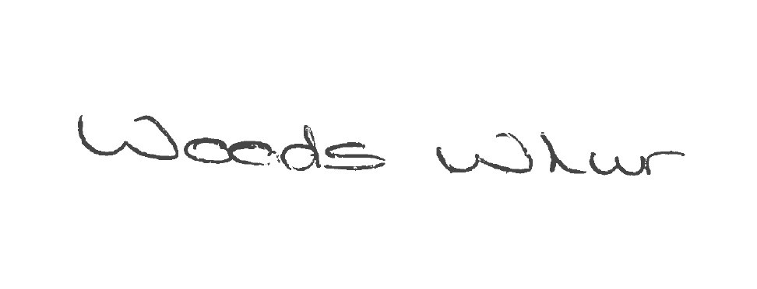
Print Name: Woods Whur
Date: 26/10//2026 Capacity: Solicitors for the Applicant

22 For joint applications, signature of 2nd applicant, or 2nd applicant's solicitor or other authorised agent. If signing on behalf of the applicant, please state in what capacity:
Signature:
Print Name: [*****]
Date: (dd/mm/yyyy) Capacity: [*****]

Part 8 – Contact Details
23(a) Please give the name of a person who can be contacted about the application: Andrew Woods
23(b) Please give one or more telephone numbers at which the person identified in question 23(a) can be contacted: 0113 234 3055
24 Postal address for correspondence associated with this application:
St James House
28 Park Place
Leeds
Postcode: LS1 2SP
25 If you are happy for correspondence in relation to your application to be sent via e-mail, please give the e-mail address to which you would like correspondence to be sent: andrew@woodswhur.co.uk

